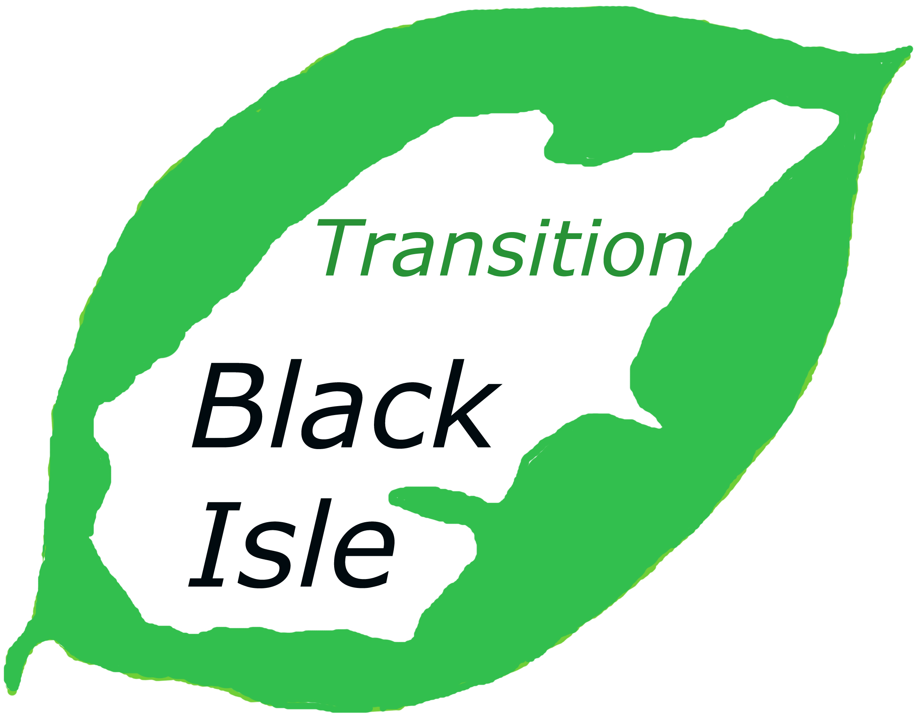

TRANSITION BLACK ISLE “MILLION MILES” PROJECT
COMMUNITY CYCLING TRAINER
JOB DESCRIPTION

£8/£10 per hour, flexible basis
Fixed term contract to 31st March 2015

Transition Black Isle (TBI) is a group of committed volunteers that aims to build local resilience to the challenges of peak oil and climate change. TBI’s Million Miles project will run up to March 2015 and aims to promote sustainable travel to Black Isle residents. The project will focus on lift-sharing, public transport, cycling and walking, and aims to reduce car use by 1%, equivalent to 1 million miles per year. The project is funded by the Climate Challenge Fund: a Scottish Government scheme to help communities reduce greenhouse gas emissions.

In year 1, the project will focus on the communities of Muir of Ord, North Kessock and Fortrose. TBI aims to recruit a team of 6 Community Cycling Trainers, 2 in each target community. The role of the Community Cycling Trainers will be to plan and deliver a series of cycling-related events, training and activities in their local community for children and adults, in order to improve cycling skills and confidence and increase cycling activity in general. Events would include group cycle rides, bike maintenance sessions, after-school clubs and holiday cycling play-schemes, in association with the Leisure Centre in Fortrose.

Community Cycling Trainer (CCT) Responsibilities

The CCTs will report to the Transport Project Officer (TPO) who will provide support and guidance as well as financial and day to day management of the CCTs’ activities. His or her specific responsibilities are listed below.

1. Working with the TPO and other CCTs to plan and deliver a programme of cycling-related events and activities for children and adults in the target communities

2. Develop relationships with local project partners such as schools and other local groups to promote the project and ensure the uptake and success of the event programme

3. Provide the TPO with regular updates in an agreed reporting format regarding uptake and success of the event programme

4. Assess the success of events through basic surveys and respond with changes and improvements, in discussion with the TPO

5. Submit regular claims for project expenditure in format agreed with TPO

6. Other relevant duties to support project activities as required from time to time

Required Experience

The preferred candidate will have experience in many of the following areas:

- Delivering training
- Communication
- Organising and coordinating
- Practical experience of cycling and bike maintenance
- Working with volunteers
- Working with children

He or she will be flexible, co-operative, open to the ideas of others and will possess excellent communication skills. An interest in promoting active travel and sustainable transport is also highly desirable. Some travel will be necessary; this should preferably be by cycle, public transport or shared lifts with other voluntary members. We hope to have CCTs working in their own local community as much as possible. It is expected that CCTs will all be cyclists themselves with access to a bike which meets safety standards.

Terms of employment

Given the nature of the project, CCTs will be employed on a zero-hours contract (i.e. no fixed hours) and be paid £8 per hour to undertake the training outlined below, and £10 per hour spent on project delivery thereafter. CCTs are expected to commit to working around 80 hours per annum. The contract will be terminated if no work is completed in a six month period. All reasonable expenses will be paid.

CCTs must complete a 4 day training course with Cycling Scotland which will be delivered locally over 2 weeks in July/August 2012. First aid training will be provided to CCTs that have not recently completed a relevant course. CCTs will also require full disclosure under the new Protection for Vulnerable Groups scheme. CCTs will be insured by TBI.

The CCTs will work flexibly to meet the project objectives; this will include a considerable element of evening and weekend working. No additional payment will be made for anti-social hours. Generally, hours of work will be agreed in advance with the TPO. CCTs will be required to complete and submit timesheets.

Attachments
Application Form
Background to TBI and Million Miles Project

For more information regarding the project or the CCT positions,
please email millionmiles@transitionblackisle.org
or call 07715 663781

Application Deadline: 14th June 2012

